**WEB SCRAPING AND ANALYSIS**

1. This project was performed on the website: <http://quotes.toscrape.com/>
2. In this project, Python language was used to extract the data around all the pages on the website.
3. Data cleaning was done to format the data and store only relevant data while exporting into a file.
4. The data was then stored into a CSV file.
5. This CSV file was later imported into Tableau and Power BI.
6. Visualization was performed on both which helped in identifying the Authors which had the most quotes, which were the Tags that were tagged the most on the quotes, etc.
7. Tableau Visualization:

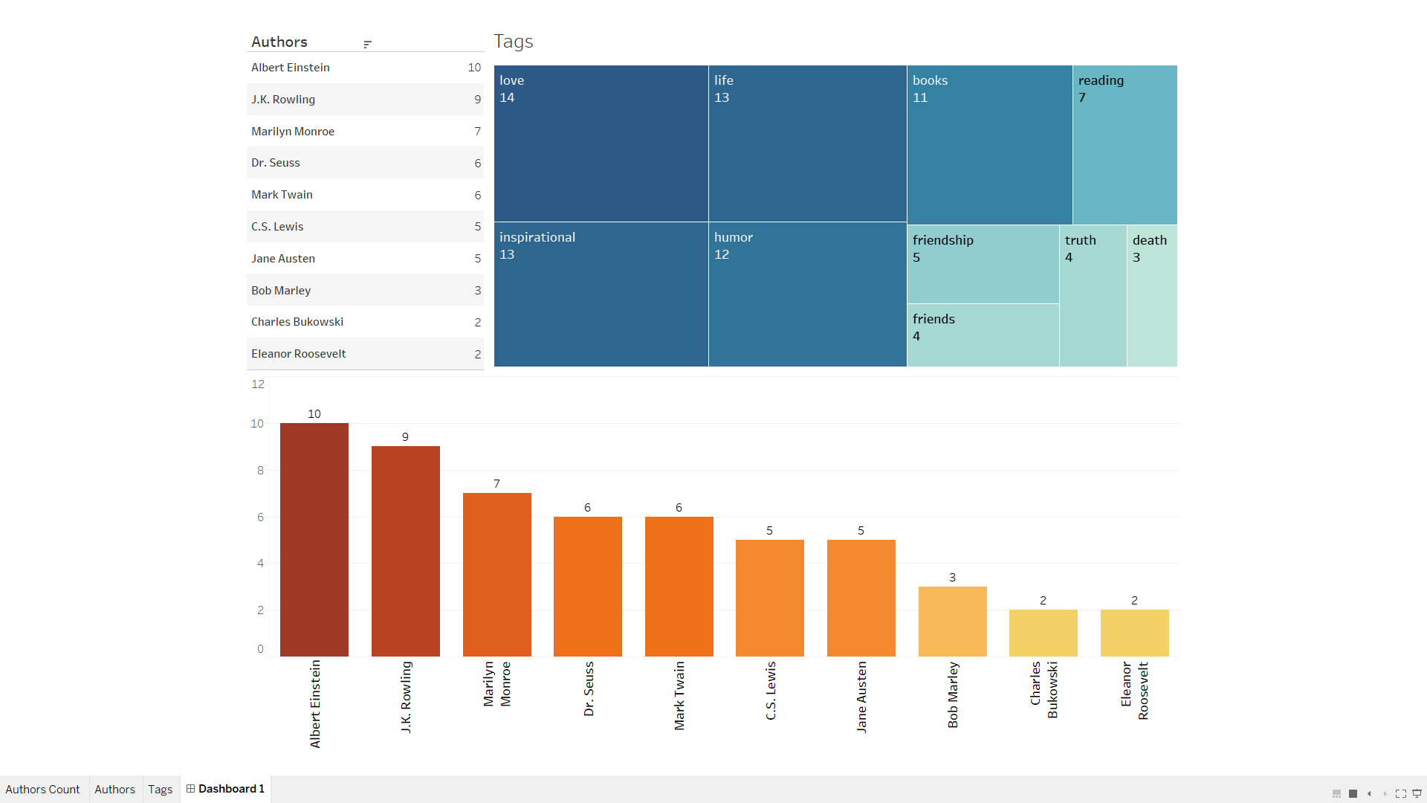

**Files:**

1. CSV and Excel Files:

 

1. Tableau Workbook:



1. Jupyter Notebooks (Web Scrape Code):



1. PDF of Dashboard:

